Cascade Track and Field Mini Camps

Dates May 28- July 18th Every Tuesday and Thursday
Open to incoming grades 7-12 at Cascade and graduates.

Times:
May 28th- June 13th: 4-5:30
Starting June 18th: 6:00-7:30

No charge. Come to get in shape and keep up the teamwork. Our focus is on technique, putting in some extra work and enjoying track and field. Come with a great attitude and work ethic.

We will also have a list of open meets you can attend if you want. Travel and expenses will be up to the athletes. We will give them information and attend those open meets when our schedules allow.

We will send changes in schedules, etc. via the Remind App. Sign-up using the directions below.

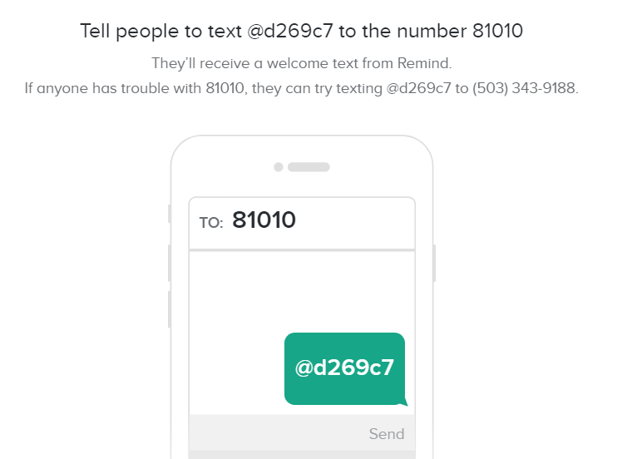

We are looking forward to seeing you!

Molly Gehley
Head Track and Field Coach
mgehley@cascade.k12.or.us

